Homework
Each week we will expect you to, if possible, upload your work onto Eschools. This guide will show you how to find what homework is set and how to upload your work.
1. First Log into Eschools – you should have been given your Eschools log in before you left school or it was included in the packs sent home to you.
If you have issues logging in, remember the username is always firstname.surname with the full stop in the middle. Also, make sure you are logging into Porthleven Eschools using our school website - http://www.porthleven.cornwall.sch.uk/website
If you are unable to log in, your parents can ring the school office and leave an email address and we will contact you to pass on your log in details.
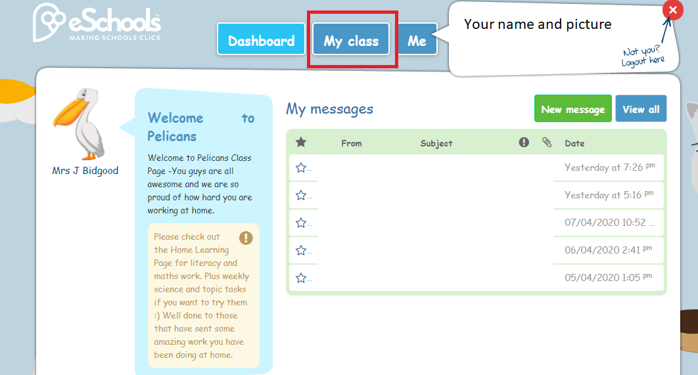
Once you are logged in, you will see your Dashboard as shown in the picture below. You need to click the ‘My Class’ link at the top.

2. My Class Screen
On here, you can look at projects, find your homework and find a list of all your classmates. You need to click on the ‘Homework’ section.
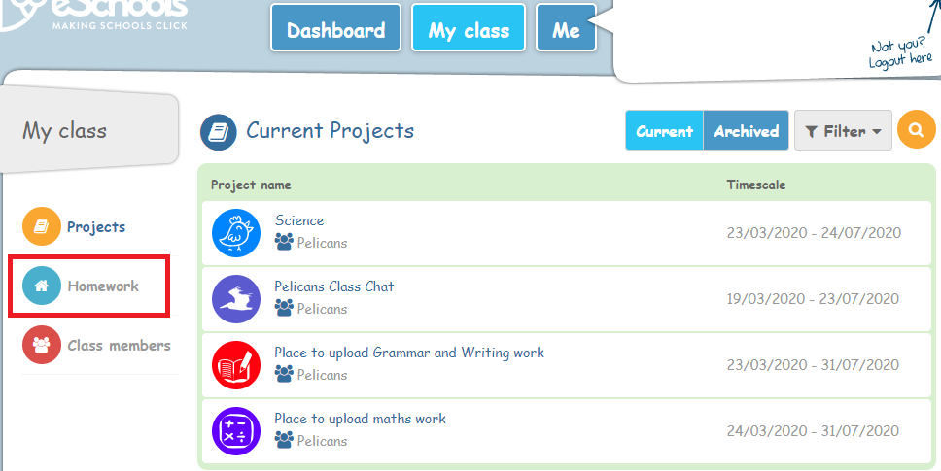
3. Your homework page
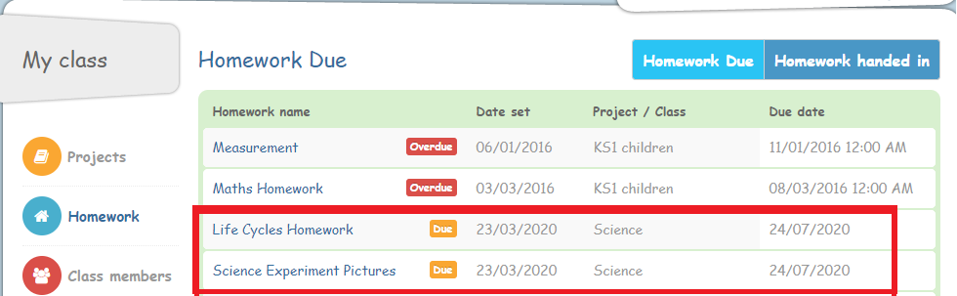
On this page, you will see homework you have been set. This is where you will find where to send us your work. There may be old homework (On the picture some from KS1!) you can ignore this
The homework will be named for which subject and week it is set and will have a due date when we would like you to send it to us by.
4. Sending Homework
When you click on the homework you will see the name, a description of the homework and who has set the homework. You have the option to upload the homework by sending us a file or you can write your homework in the box below and type it up directly onto Eschools.
If you want to upload your work, you can upload a word document, pdf, publisher, paint picture, PowerPoint, video or photo. If you’ve written work in your books we provided please take a photograph of your work to upload that we can read
If you get stuck how to upload your work, ask an adult at home or older sibling to help you if they can.
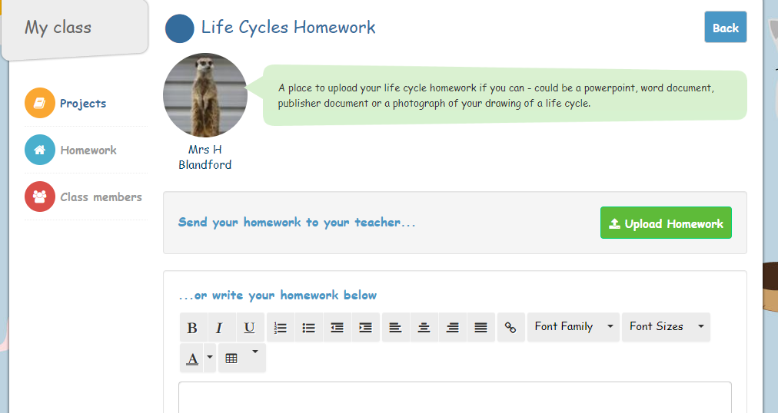

Hope that helps, if you are struggling please message your class teacher for help with any homework or how to send it to us. Here is a video recapping this for you - https://youtu.be/Yi48eDbU-Kg

